SAI VIDYA INSTITUTE OF TECHNOLOGY
(Affiliated to Visvesvaraya Technological University, Belagavi | Recognized by Govt. of Karnataka | Approved by AICTE, New Delhi)
Accredited by NBA, New Delhi
Rajanukunte, Bengaluru- 560 064

DEPARTMENT OF COMPUTER SCIENCE AND ENGINEERING
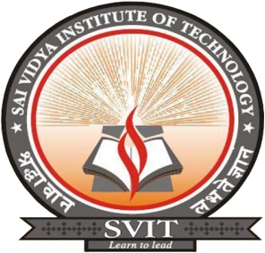

CERTIFICATE

Certified that the Internship work entitled “Course Portal: Design and Implement the Backend Server (Timer, User Response Time, Unauthorized Access) for online MCQ/SBQ platform” carried out at “K-AKA Technology” by Darshika B (1VA18CS009), a bonafide students of SAI VIDYA INSTITUTE OF TECHNOLOGY, Bengaluru, in partial fulfillment for the award of Bachelor of Engineering in Computer Science and Engineering of VISVESVARAYA TECHNOLOGICAL UNIVERSITY, Belagavi during the year 2021-22. It is certified that all corrections/suggestions indicated for Internal Assessment have been incorporated in the Report deposited in the departmental library. The Internship report has been approved as it satisfies the academic requirements in respect of Internship prescribed for the said Degree.

Prof. Sreelatha P K  Assistant Professor,  Dept. of CS&E, SVIT | Dr. Shantakumar B Patil  Professor & HOD,  Dept. of CS&E, SVIT | Dr. H S Ramesh Babu  Principal,  SVIT
Internship Marks Allotment
Report (25) | Seminar/Presentation (25) | Total (50) | Signature of Guide
External Viva:
Name | Signature
- ___________________________ | __________________________
- ___________________________ | __________________________

